BJT Amplifier HW2 (22 points)
(jas, BJT Amplifier HW2.docx, 10/04/2024)

Clearly indicate answers and include units for numeric answers, using 3 or 4 significant figures. Show at least the major steps of your work so that if necessary partial credit can be awarded.

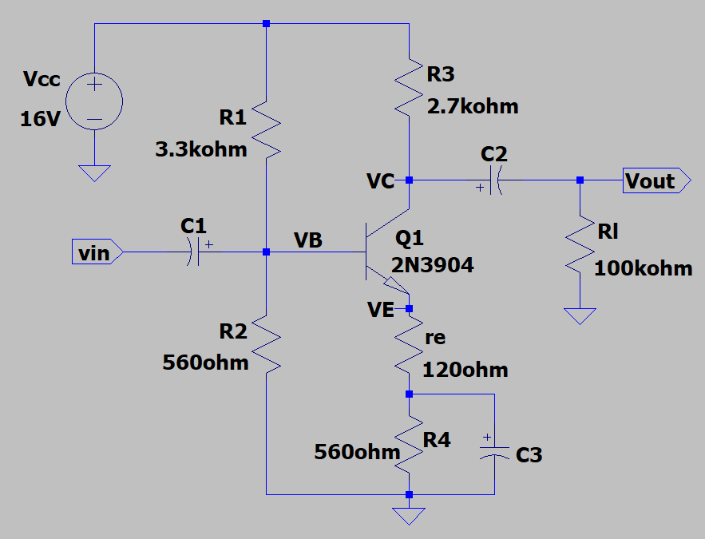
- For the adjacent Voltage Divider Bias (VDB) amplifier circuit with ac emitter feedback, calculate the following values assuming a β of 300 using simplified analysis. (Hint: Z_{in} should be between 460 and 480 Ω.)
(10 points total.)

- $r_{e}^{'}$ (4 Points.)
$$I_{e}=\frac{\frac{R2}{R1+R2}\left(V_{CC}\right)}{r_{e}+R4}=\frac{\left(\frac{560 }{3.3*{10}^{3}+560 }Ω\right)\left(16V\right)}{120 Ω+560 Ω}$$
$$I_{e}=3.4 mA$$
$$r_{e}^{'}=\frac{25mV}{I_{E}}=\frac{25mV}{3.4mA}=7.32Ω$$
$$r_{e}^{'}=7.32Ω$$

- r_{c} (2 Points.)
$$r_{c}=R3∥Rl=2.7kΩ∥100kΩ=2.63kΩ$$
$$r_{c}=2.63kΩ$$

- A_{V} (2 Points.)
$$A_{v}=-\frac{r_{c}}{r_{e}}=-\frac{2.63kΩ}{7.32Ω}=358.98$$
$$A_{v}=358.98Ω$$

- Z_{in} (2 Points.)
$$Z_{in}=R1∥R_{2}∥β\left(r_{e}^{'}+r_{e}\right)$$
$$\frac{1}{Z_{in}}=\frac{1}{3.3kΩ}+\frac{1}{560Ω}+\frac{1}{300*\left(7.32Ω+120Ω\right)}$$
$$Z_{in}=\frac{1}{\frac{1}{3.3kΩ}+\frac{1}{560Ω}+\frac{1}{300*(7.32Ω+120Ω)}}=472.8Ω$$
$$Z_{in}=472.8Ω$$

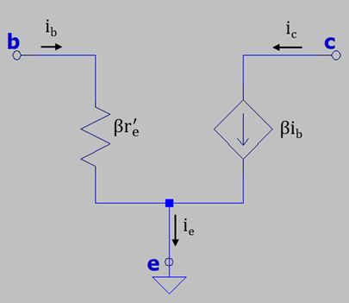
- The simplified small-signal π model for a Bipolar Junction Transistor (BJT) operating in the active region is illustrated in the adjacent figure, where $r_{e}^{'}$ is the base-emitter dynamic diode resistance inside the BJT, β is the ac current gain of the transistor with i_{c} = βi_{b} by means of the dependent current source control equation. This can be modeled in LTspice by means of an Arbitrary Behavioral Current Source, which is the bi component available in the main library. (Note: You must use the bi component, rather than the current component to implement the necessary control equation.) (12 points total.)

Construct the LTspice simplified small signal π model illustrated below, including your name on your schematic. Replace the schematic shown below with your version. (4 points.)
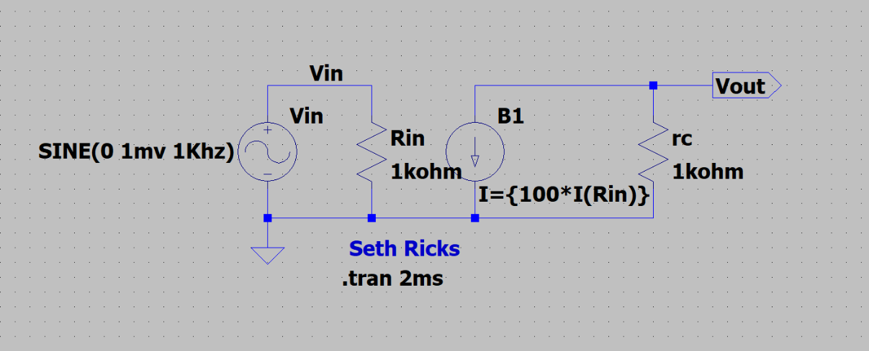
Figure 2: LTspice Simplified Small-Signal π model for a BJT operating in the active region.

The βi_{b} dependent current source is to be modeled by means of the bi component utilizing the Behavioral Equation I = {100*I(Rin)} for β = 100. The AC voltage source symbol for Vin is available in the Misc folder in the parts library as a signal component.
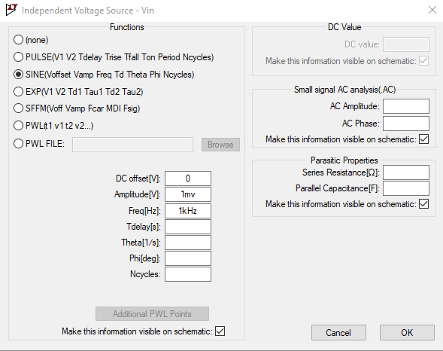
Voltage source Vin is to be set as a sinusoidal source for Transient Analysis, which can be done by means of the Independent Voltage Source pane as illustrated in the adjacent figure. In the Independent Voltage Source pane, set the Functions to SINE(Voffset Vamp Freq Td ThetaPhi Ncycle), with Voffset = 0, Vamp = 1mV, and Freq = 1 kHz, as illustrated in the adjacent figure.

After running the Transient Analysis simulation, add a 2nd plot pane by means of the Plot Settings pull down menu as, Plot Settings Add Plot Pane. Select the V(vin) trace for the top plot pane, and the V(vout) trace for the bottom pane. Also annotate your plot pane with your name by means of the Plot Settings → Notes and Annotations → Place Text options available by accessing the Plot Settings pulldown menu above the toolbar. Replace the plot panes shown below with your simulated results. (4 points.)
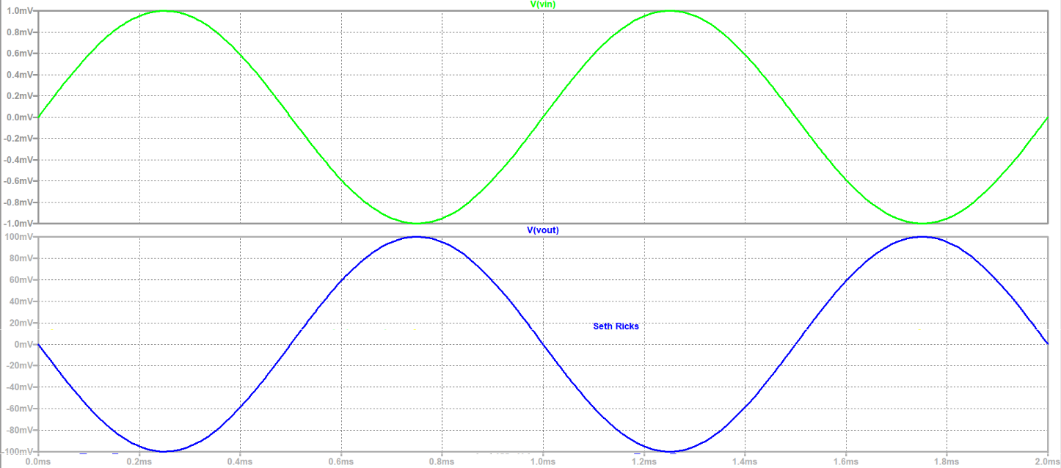

Based on your simulated results, determine the voltage gain A_{V} including the sign.
(2 points.)

A_{V} = $\frac{V_{out}}{V_{in}}=\frac{100mV}{-1mV}=-100$
$$A_{V}=-100$$

Using a complete sentence or sentences, describe what changes can be made to your LTspice small-signal equivalent circuit to increase the magnitude of the voltage gain, given a fixed β = 100 and fixed value of Rin = 1 kΩ. (2 points.)

In order to increase the magnitude of the voltage gain, you can change the value of the resistor rc. For example, changing rc from 1 $kΩ$ to 10 $kΩ$ changes the gain from -100 to -100. This is because the gain can be found by the equation: $A_{V}= -\frac{r_{c}}{r_{e}}$, so increasing $r_{c}$ would increase the gain. If we had the option, we could also decrease $r_{e}$ to increase the gain.

